Name: Kaveri Avinash Jarhad

Assignment 2 (IP Addressing)
- What is IP Addressing?
IP Addressing (Internet Protocol Addressing) is the system used to assign unique numerical identifiers to devices connected to a computer network. An IP address serves two main functions: identifying the host (or network interface) and providing its location in the network so data packets can be routed correctly.
Anatomy of an IP Address
Every IP address consists of two distinct components:
- Network ID: Identifies the specific network where the device resides.
- Host ID: Identifies the specific device on that network.
The boundary between the Network ID and Host ID is defined by a Subnet Mask (e.g., 255.255.255.0 or CIDR notation like /24).

- What are the Different Versions of IP Addresses?
The two active operational versions of Internet Protocol (IP) addresses used across public and private networks are IPv4 and IPv6.
Historically, IP versions 0 through 3 were experimental protocols developed between 1977 and 1979 during the creation of TCP/IP. IPv5 (Internet Stream Protocol) was an experimental streaming protocol that was never deployed publicly.

Primary IP Versions in Production
Feature | IPv4 (Internet Protocol v4) | IPv6 (Internet Protocol v6)ollama
Status | Active (Standard / Legacy) | Active (Modern Standard)
Address Length | 32 bits (4 bytes) | 128 bits (16 bytes)
Format Notation | Dotted Decimal (e.g., 192.168.1.1) | Colon-Hexadecimal (e.g., 2001:0db8:85a3::8a2e:0370:7334)
Structure | 4 octets of 8 bits each | 8 hextets of 16 bits each
Configuration | DHCP or manual | SLAAC (Stateless Auto-config) or DHCPv6
IPsec Support | Optional | Built into base specification

Overview of Historical & Experimental Versions
- IPv1 – IPv3 (1977–1979): Early design iterations of TCP/IP during DARPA research. In these draft stages, the network protocol and transport functions were merged before being split into separate TCP and IP layers in IPv4.
- IPv4 (1981 – Present): Defined in RFC 791, this became the first publicly deployed version and still handles a major portion of global internet traffic.
- IPv5 (1979 / 1990): Defined as the Internet Stream Protocol (ST) in RFC 1190. It was designed to stream voice, video, and real-time data over packet networks. Because it used the same 32-bit addressing structure as IPv4 and did not solve address exhaustion, it was abandoned in favor of IPv6 development.
- IPv6 (1998 – Present): Defined in RFC 2460 (updated in RFC 8200) to solve the depletion of IPv4 addresses. It introduces stateless address autoconfiguration, simpler packet headers, and built-in IPsec security.

- Describe IPv4 in Detail.
  - What is IPv4?
  - How is it structured (bit length, dotted decimal format)?
Internet Protocol version 4 (IPv4) is a fundamental communications protocol in the Internet Protocol Suite (TCP/IP). It operates at the Network Layer (Layer 3) of the OSI model and is responsible for identifying devices on a network through logical addressing, as well as routing data packets between source and destination endpoints across interconnected networks.

Structure & Representation
An IPv4 address is a numeric identifier with a fixed length and structure:
- Bit Length: IPv4 uses a 32-bit binary address space ($2^{32}$ total addresses, or approximately 4.29 billion distinct addresses).
- Octets / Bytes: The 32 bits are evenly divided into 4 octets (sections), where each octet consists of 8 bits ($4 \times 8 = 32\text{ bits}$).
- Dotted-Decimal Notation: Because raw binary string sequences (such as 11000000101010000000000100000001) are difficult for human readability, IPv4 addresses are converted into decimal form separated by periods (dots).
Component | Binary Representation | Decimal Representation
Octet 1 | 11000000 | 192
Octet 2 | 10101000 | 168
Octet 3 | 00000001 | 1
Octet 4 | 00000001 | 1
Combined | 11000000.10101000.00000001.00000001 | 192.168.1.1
Because an 8-bit binary number ranges from 00000000 ($0$) to 11111111 ($255$), each decimal value in an IPv4 address must fall inclusively between 0 and 255.

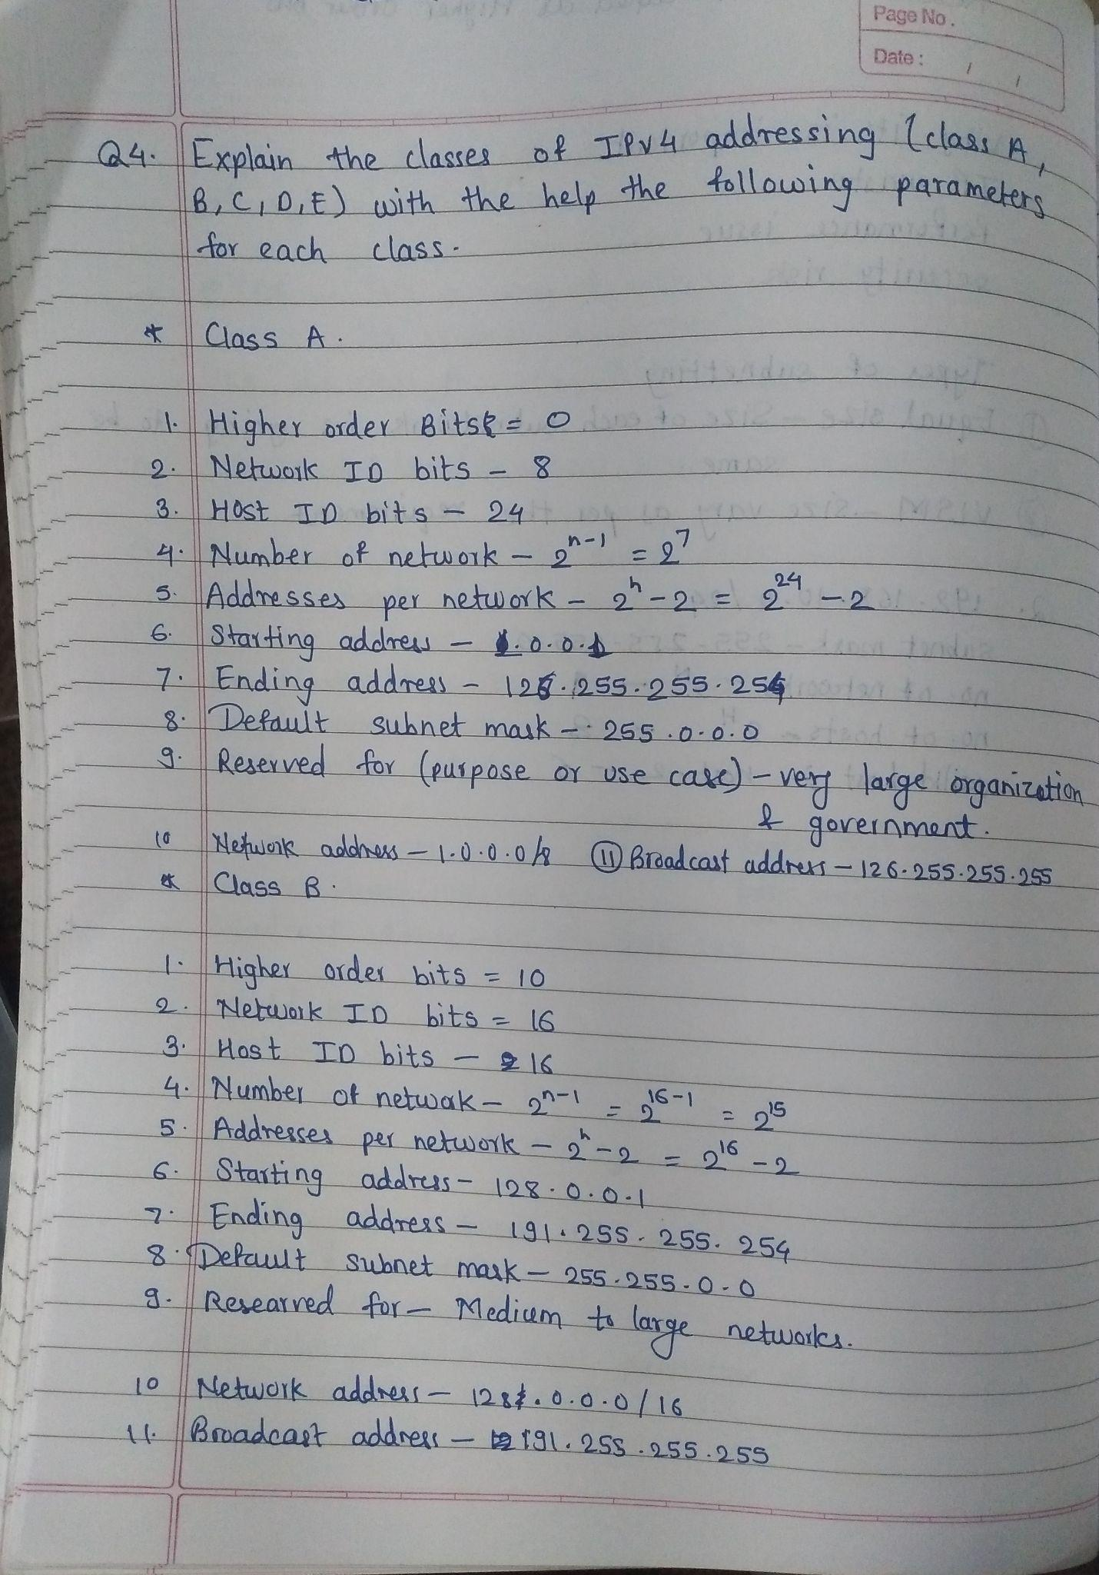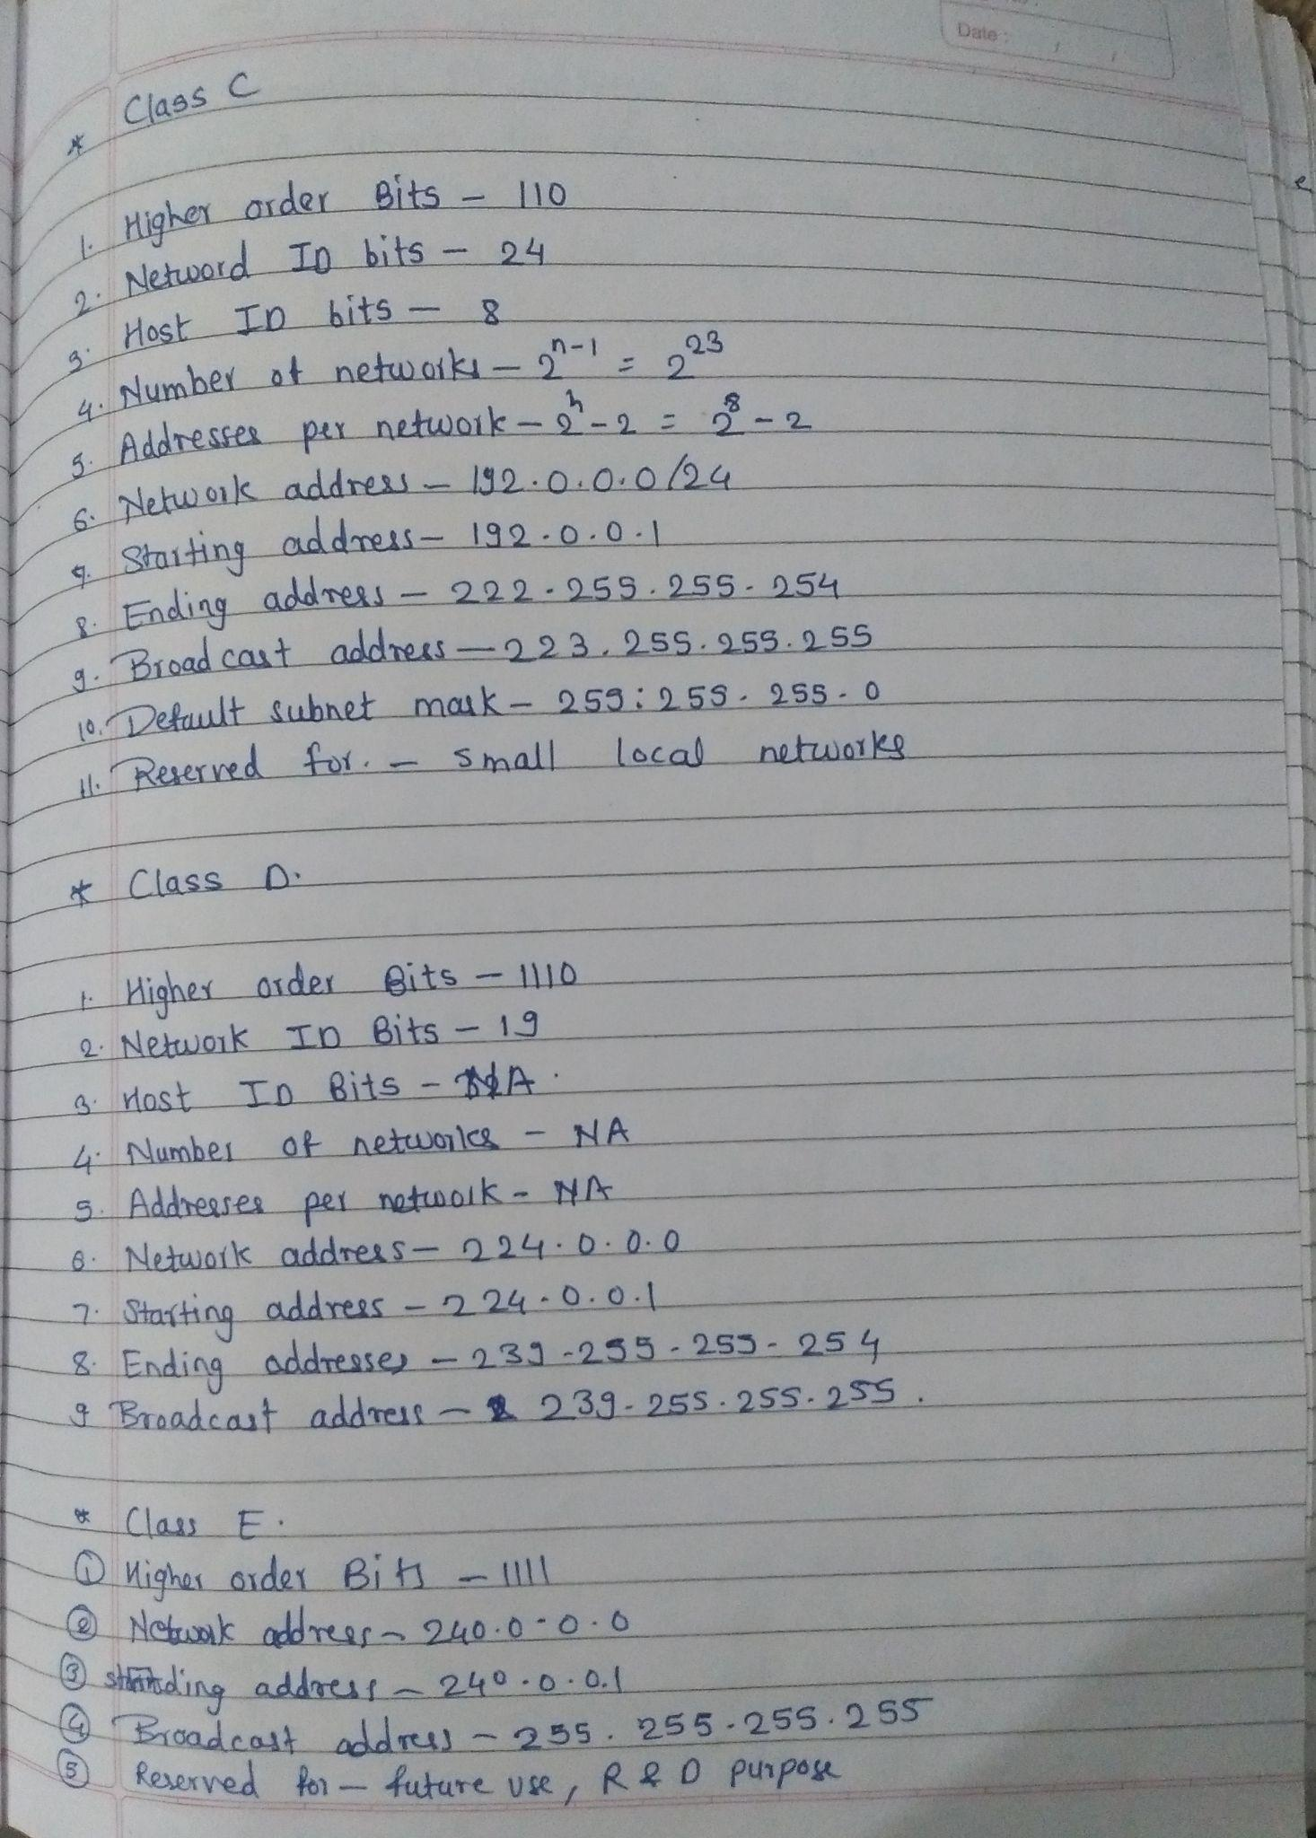
Assignemnt 2 (Broadcasting)

1. What is Broadcasting?
Broadcasting in computer networks is a type of communication mechanism that allows the message to be received by all the nodes of a network. The term broadcast in general refers to the transmission of signals from radio or televisions.
Every broadcasted signal is stopped at layer-3 network layer of OSI or to be more practical - at the router. A more technical example of Broadcasting would be: The Address-Resolution-Protocol request (ARP-Request) whenever a host needs to resolve an IP address to its corresponding MAC address it will broadcast a signal asking "Who this IP address belongs to?" and this broadcasted signal is received by every single node in a network domain and then an appropriate node will respond accordingly.

Types of Broadcasting
There are 3 types of broadcasting mainly :

1. Limited Broadcast
It is a simplest broadcasting in which a message is transmitted to every node within a same network (the destination node exists within the same network), the scope of broadcast doesn't go beyond the local network. And an example IPv4 address would be - 255.255.255.255, and IPv6 : FF02::1

2. Directed Broadcast
In directed Broadcast, the message is sent to a specific group of hosts within a network that can be identified by their subnets. And the host bits of the destination IPv4 address are all set to 1. Example: 192.168.1.255

3. Subnet Broadcast
Subnetting refers to creating a smaller network within a larger network that shares a common network address. Whenever a message is to be broadcasted to a specific subnet within a larger network then its called subnet Broadcast. In this, the message is sent to the broadcast address of a specific subnet and the broadcast address of a subnet is the highest possible address. For example if the subnet address is : 192.168.1.0 & the subnet mask is 255.255.255.0 then the broadcast address would be 192.169.1.255.

2. Where is Broadcasting commonly used?
Broadcasting in computer networks sends a single packet from one sender to all connected devices on the same local network segment (broadcast domain). Because sending packets to every node consumes significant bandwidth and processing power, broadcasting is strictly limited to Local Area Networks (LANs) and is routinely blocked by routers to prevent wide-scale network congestion.
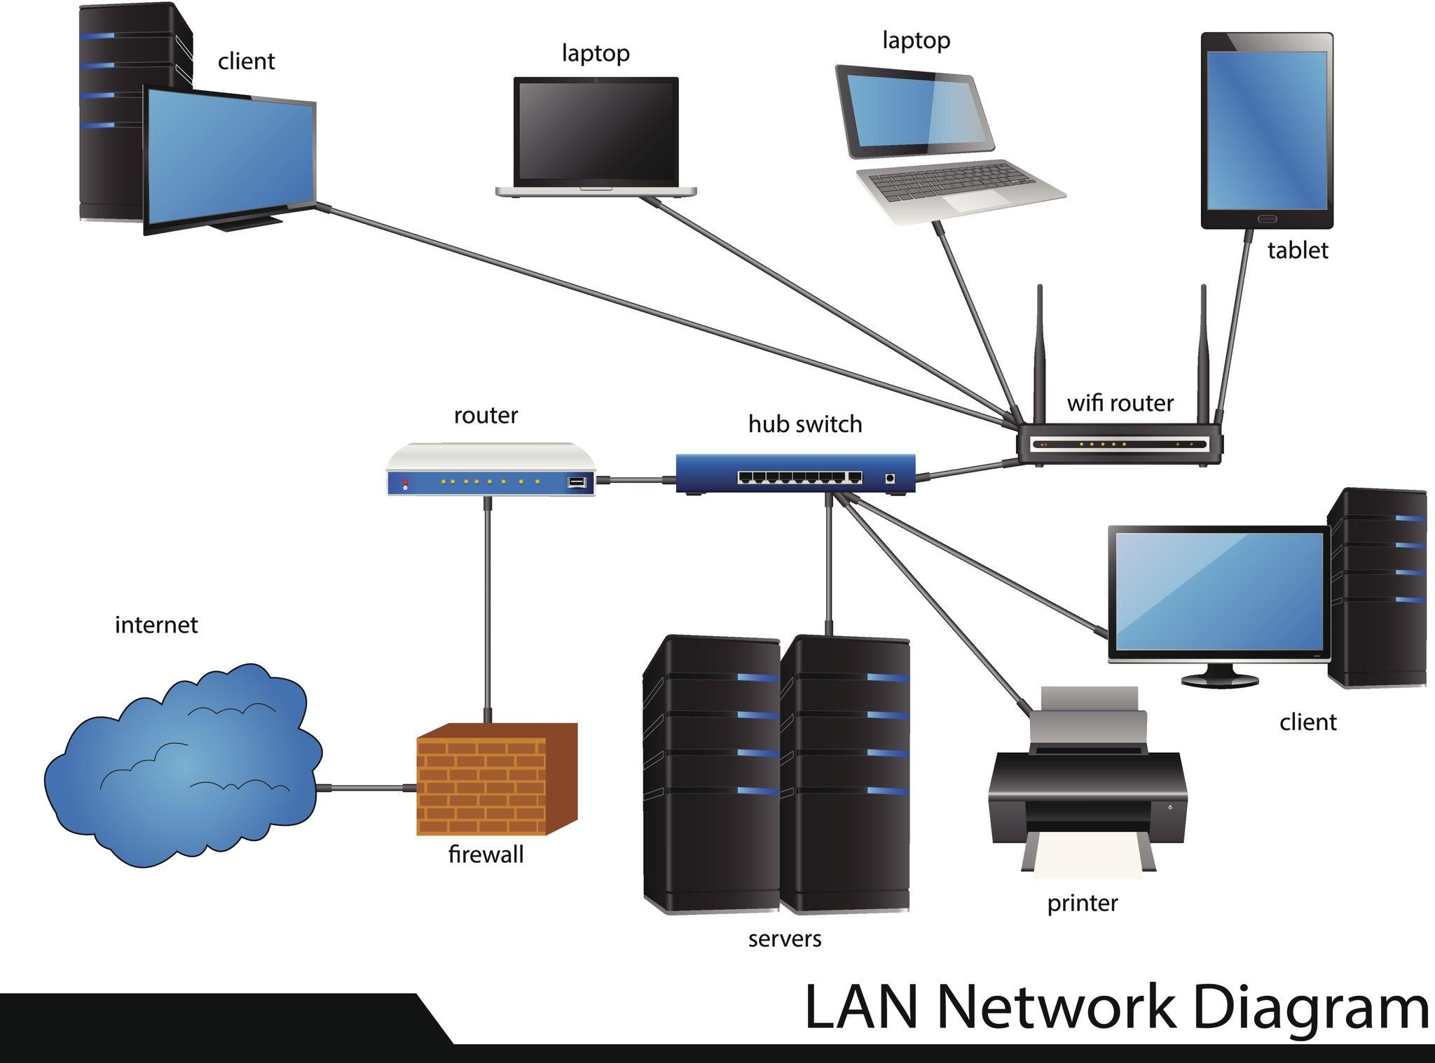
Primary Use Cases
- Address Resolution Protocol (ARP): When a host knows the target IP address but needs the corresponding MAC address, it broadcasts an ARP Request (FF:FF:FF:FF:FF:FF) across the local layer-2 segment asking, "Who has this IP?"
- Dynamic Host Configuration Protocol (DHCP): When a new device joins a network without an IP address, it broadcasts a DHCPDISCOVER packet to locate any available DHCP server on the LAN segment.
- Service Discovery Protocols: Technologies like mDNS (Multicast/Broadcast DNS), SSDP (Simple Service Discovery Protocol), and NetBIOS broadcast queries to discover printers, smart TVs, and shared resources without manual configuration.
- Network Routing Updates: Legacy routing protocols (such as RIPv1) broadcast entire routing tables to neighboring routers every 30 seconds to keep network topology synchronized.
- Network Diagnostics and Wake-on-LAN (WoL): Administrators send broadcast "magic packets" across a LAN to wake up sleeping machines remotely or trigger local network-wide system announcements.

3. What are the drawbacks of Broadcasting?
While broadcasting is essential for initial network discovery and address resolution, relying on it introduces several critical performance, security, and scalability drawbacks.
Major Drawbacks
- High Bandwidth Consumption: Every broadcast packet travels across every wire and switch port within the broadcast domain. Frequent broadcasting consumes a significant portion of available network throughput, reducing bandwidth for actual user traffic.
- CPU Overhead on End Devices: Unlike unicast traffic, which network interface cards (NICs) filter at the hardware layer, every host receiving a broadcast frame must pass it up to the OS kernel and CPU to inspect its payload—even if the packet is completely irrelevant to that device.
- Risk of Broadcast Storms: If a loop exists in a switched network (e.g., due to redundant physical connections without Spanning Tree Protocol enabled), broadcast frames loop indefinitely. They multiply exponentially within seconds, locking up switches and causing a total network outage.
- Security & Privacy Risks: Broadcast packets are inherently unencrypted and public to the local segment. Any device on the subnetwork—including a rogue or compromised device—can capture these packets to map the network topology, sniff network requests, or conduct ARP spoofing attacks.
- Poor Scalability: As the number of devices on a local subnet grows, the volume of broadcast traffic increases exponentially. This hard limit forces network engineers to segment large networks into smaller VLANs to keep broadcast traffic contained.

